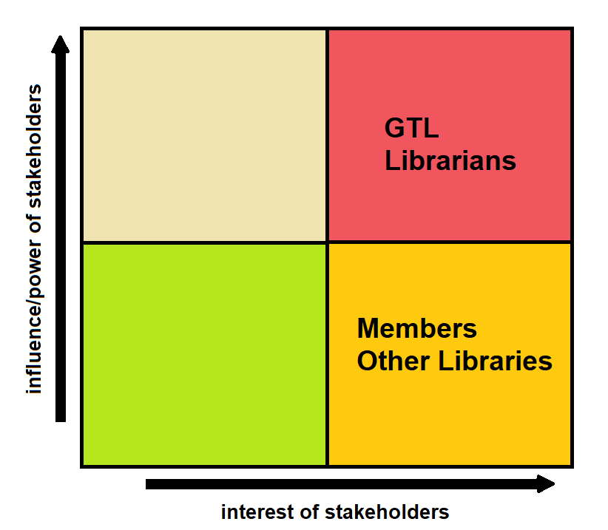In this section we will go into greater details describing the various stakeholders of the final software solution. In total, there are four stakeholders that we managed to identify

Stakeholders are as follows:

1. Georgia Tech Library – One of the stakeholders who has the most power and interest over the application. Its aim is to improve the current way of handling books and gathering statistical information about the library usage, therefor placed in the red area.
2. The librarians – The second most influential and interested entities, their interest is in making their work easier and faster by the help of the application.
3. Members of the library – Students or Professors who are part of the library both benefit from the software solution as it would be easier to keep track of their loans or the books they want to rent, although they have a high interest in the solution, they have a considerably smaller influence on the final product compared to the librarians and GTL
4. Other libraries – Also of high interest but low on influence, the other libraries are looking to ease and speed up communication between them and GTL.